**Main courses**

Norwegian Meatballs (6X)

**Directions (6x)**

Grind meat together 5 times.

Combine seasonings with flour (hydrate onions in ¼ C water). Using hands, mix into meat. Mix in one egg at a time. Gradually add half and half, until spongy and light. Shape into balls with a small dipper chilled in ice water!

Drop into simmering beef stock, cook about 5 mins. In fry pan, brown in butter and a little oil. Put cooked balls in roaster pan, cover with beef broth, and freeze.

Thaw meatballs in broth at least two days before use. Warm meatballs at 325° until all ice crystals gone. Drain broth from meatballs and make gravy. Add thickened broth to meatballs and warm at 225° until ready to serve.

Gravy: Mix 1 C cold water with 1 C flour in blender. Add flour mixture slowly to 7 C boiling broth (drained from meatballs) along with 2 tsp kosher salt and some pepper. Cook until thickened and add back to meatballs.

**Ingredients**

**12 lb – ground chuck**

**3 lb – ground pork**

**9 tsp – kosher salt**

**1 tsp – pepper**

**1 ½ tsp – nutmeg**

**1 ½ tsp – ginger**

**6 tsp – dehydrated onion**

**¾ C – flour**

**12 eggs**

**2 qt – half and half**

**9 qt – beef stock**

**MAKES**

**60 servings – 600 meatballs**

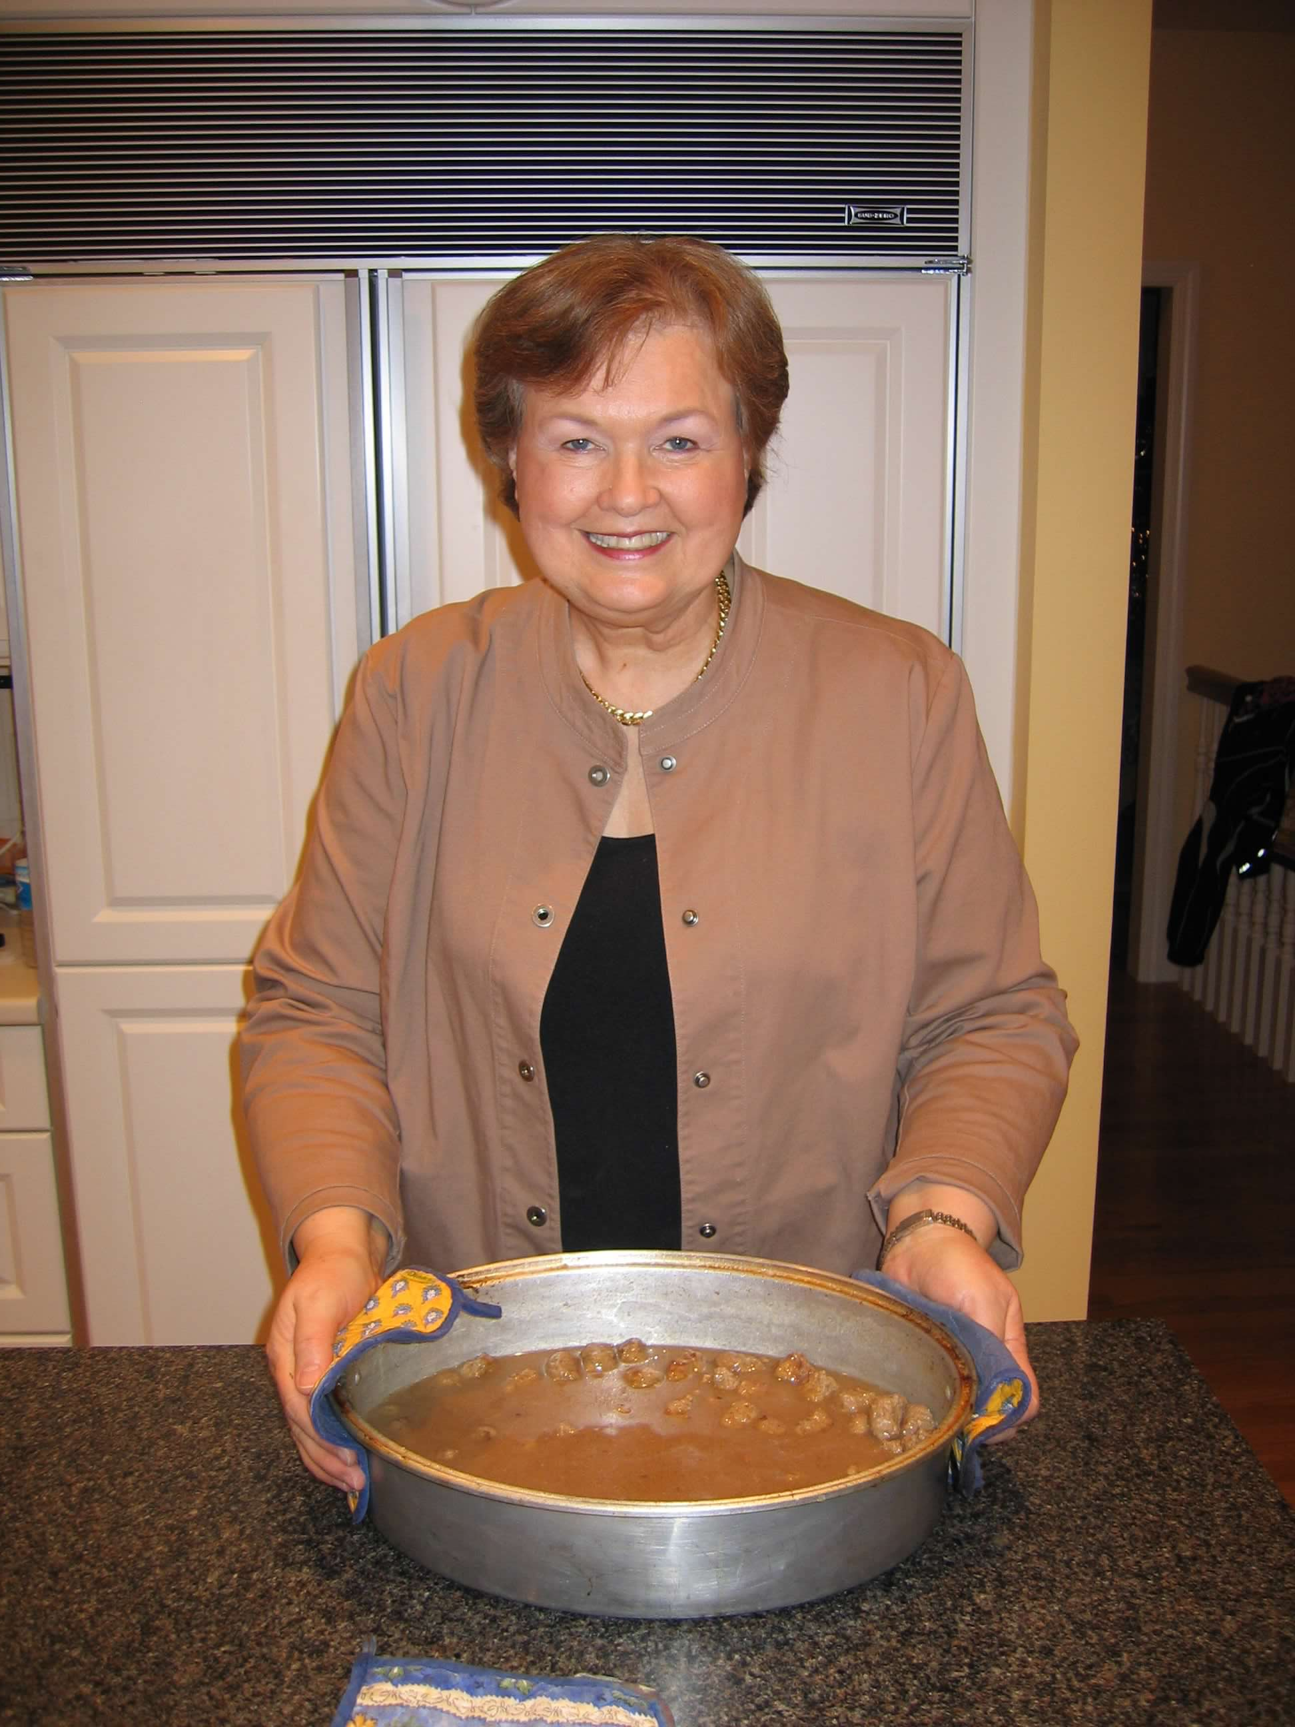

**Main Courses**

Norweigan Meatballs (GF)

**Directions (GF)**

Grind meat together 5 times.

Combine seasonings with flour (hydrate onions in ¼ C water). Using hands, mix into meat. Mix in one egg at a time. Gradually add half and half, until spongy and light. Shape into balls with a small dipper chilled in ice water!

Drop into simmering beef stock, cook about 5 mins. In fry pan, brown in butter and a little oil. Put cooked balls in roaster pan, cover with beef broth, and freeze.

Same thawing and warming directions.

Gravy: Mix 1 C cold water with 2/3 C tapioca flour in blender. Add flour mixture slowly to 7 C boiling broth (drained from meatballs) along with 2 tsp kosher salt and some pepper. A little more tapioca flour may be needed. Cook until thickened and add back to meatballs.

*This adapted recipe replaces traditional flour with almond flour (1:1) in balls and tapioca flour (3:2) in gravy.

**Ingredients**

**8 lb – ground chuck**

**2 lb – ground pork**

**6 tsp – kosher salt**

**4 dashes – pepper**

**1 tsp – nutmeg**

**1 tsp – ginger**

**4 tsp – dehydrated onion**

**8 T – almond flour**

**8 eggs**

**1 qt – half and half**

**6 qt – beef stock**

**MAKES**

**40 servings – 400 meatballs**

